

Department of Electronic and Telecommunication Engineering  
University of Moratuwa

EN2160 – Preliminary Design Report  
Morse Code Encoder Decoder

THILAKARATHNE D.L.J. 200650U

This report is submitted as partial fulfilment of the module EN2160 - Electronic Design Realization  
16 June 2023

Schematic and Solid work design of the implemented design

Schematic

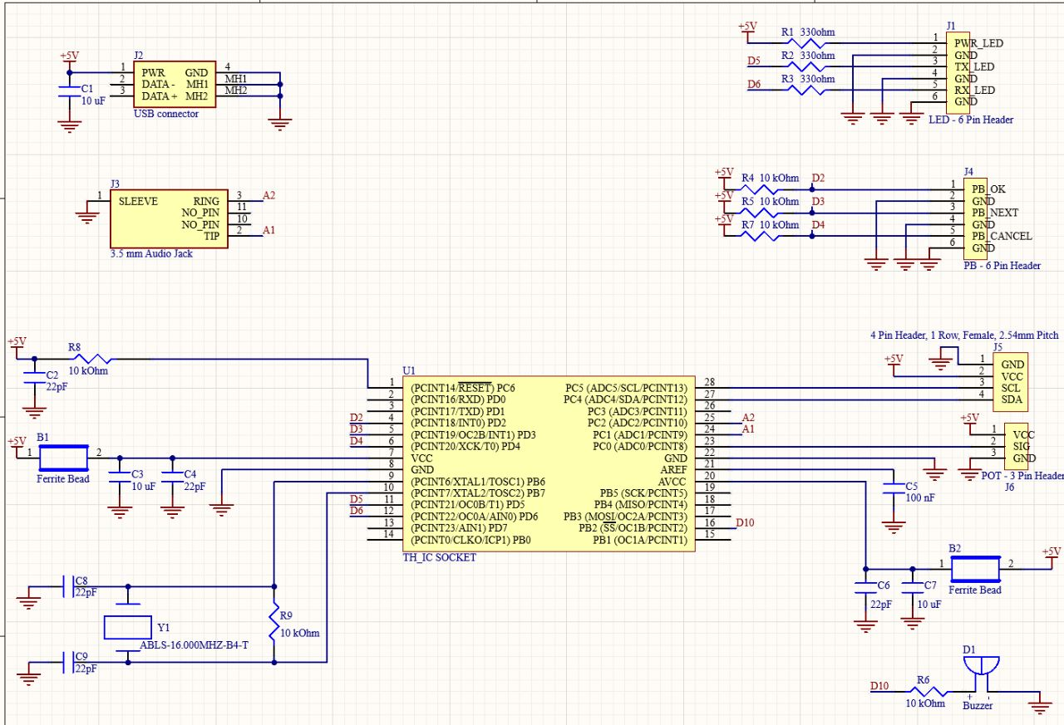

Solid work design

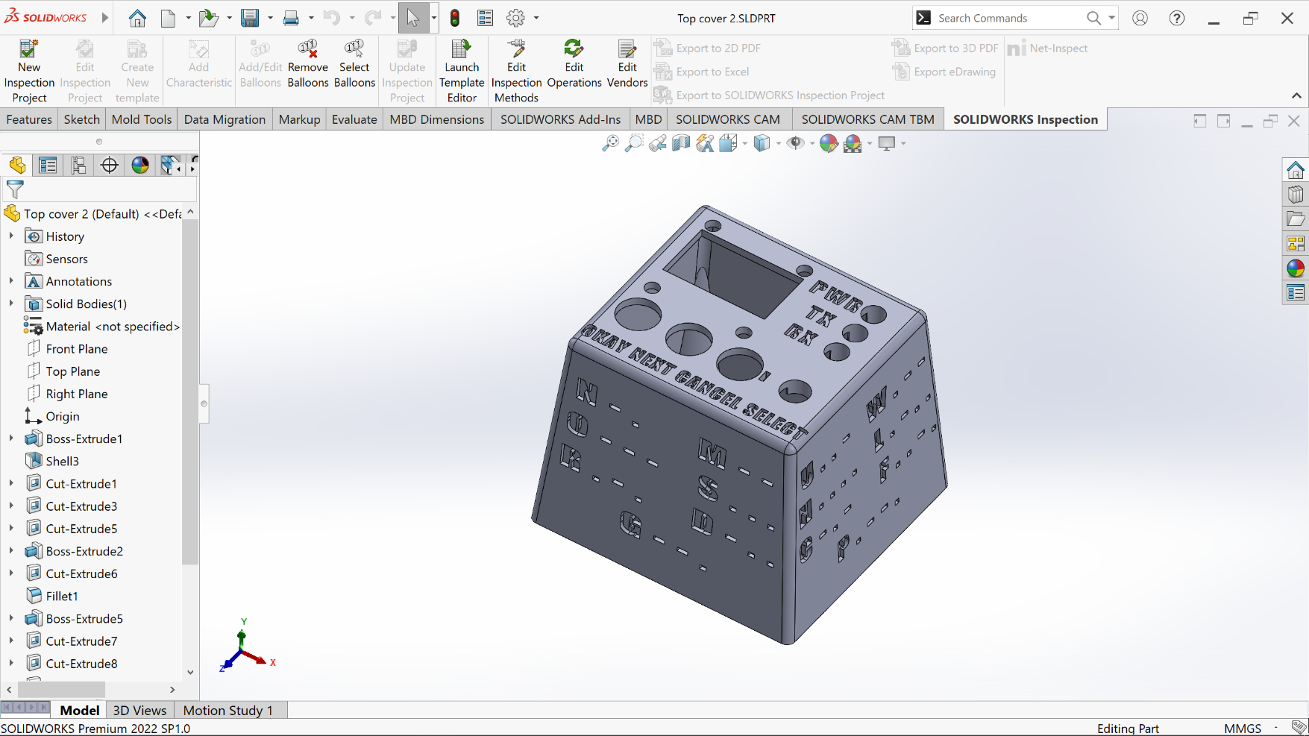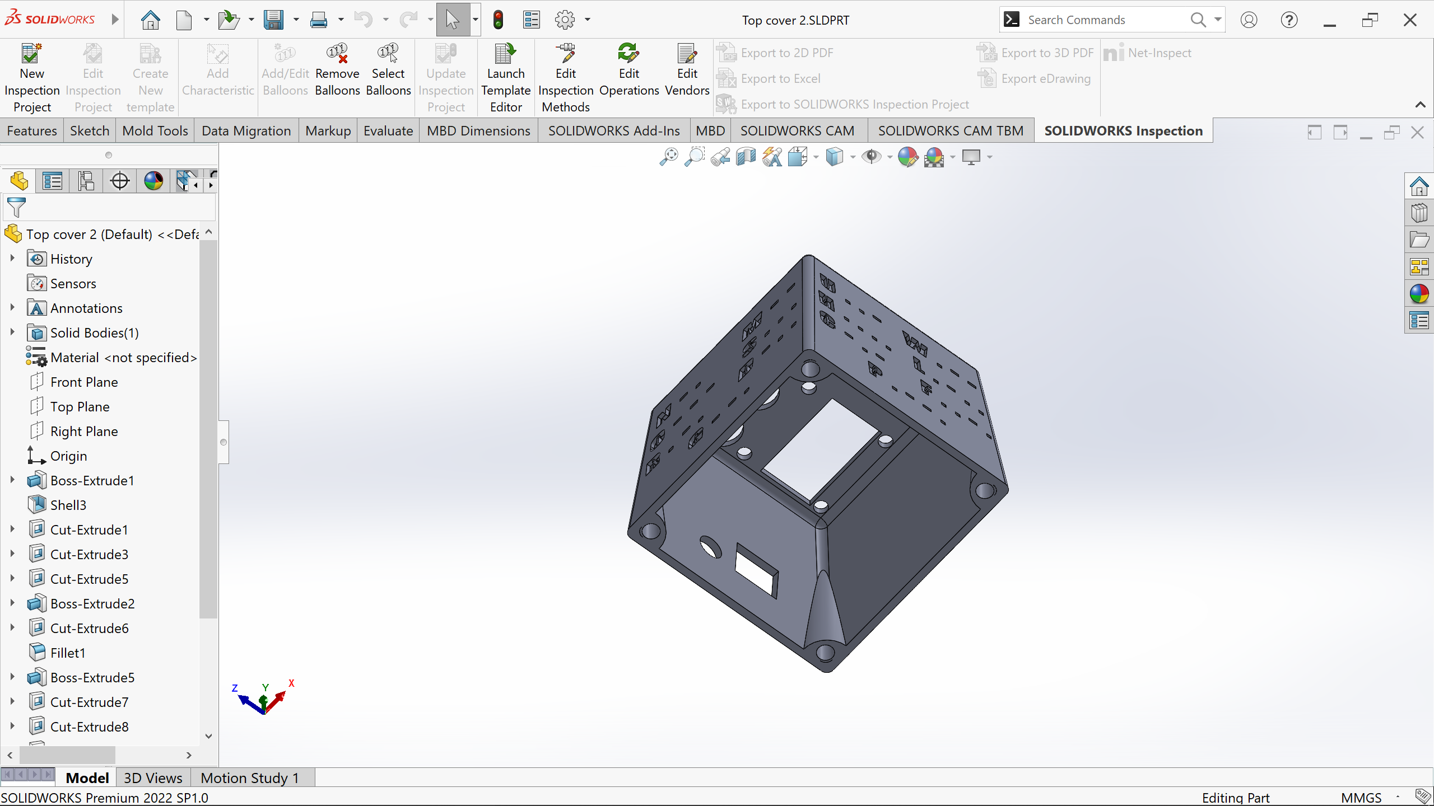

According to the draft analysis, this cannot be injection moulded.

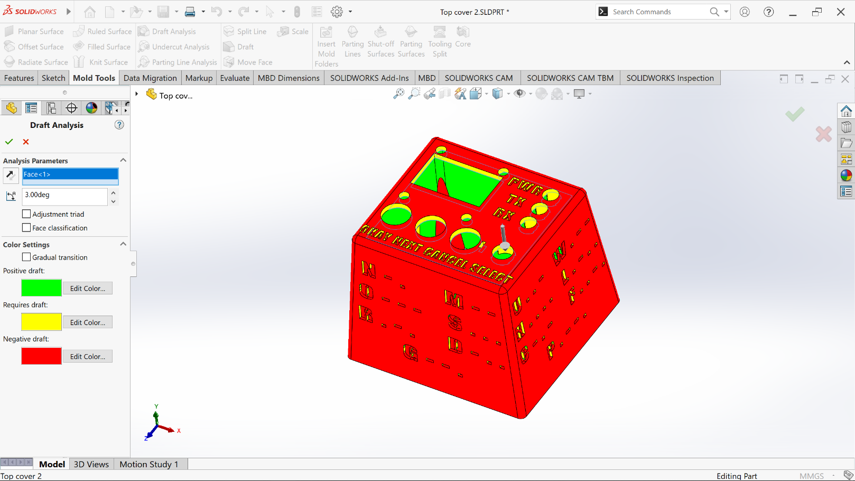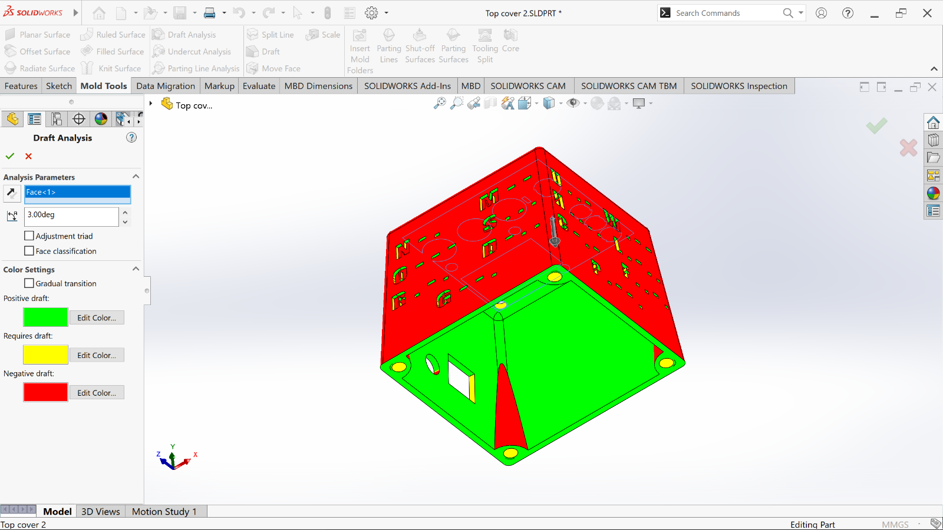

Problems identified by you considering the course contend delivered by Prof. Jayasinghe

Schematic

* The annotations do not adhere to the expected professional standards as mentioned by Prof. Jayasinghe. Specifically, they are not arranged in a sequential manner from left to right and top to bottom as required.
* The placement of inputs and outputs is incorrect. Prof. Jayasinghe recommended that inputs be positioned on the right side, while outputs should be positioned on the left side.
* The schematic is hard to read and comprehend. It should be simplified. The example schematic design provided by Prof. Jayasinghe is a proper reference to how a professional schematic should be.

Solid work design

* I was previously unaware of the intricacies involved in injection moulding and the manufacturing process of a product. However, thanks to the invaluable teachings of Prof. Jayasinghe, I have gained a newfound understanding. Upon examining the draft analysis, I have come to the realization that the enclosure of my product is unsuitable for injection moulding. Notably, the yellow-coloured areas depicted in the images present challenges as they cannot be effectively moulded, particularly the intricate lettering.

Problems/Improvements identified/proposed by members of your group

* One suggestion was made to increase the volume of the buzzer. The resistance value of the resistor which connects to the buzzer was then reduced.
* Another suggestion was made to increase the button debounce time. Since that typically causes errors. That was adjusted as required.

Problems/Improvements identified/proposed by users

* One user suggested to make the ports reside a little bit inwards. (Not to make them pop out of the enclosure.) That was adjusted as required.

Schematic and Solid work design of the improved design

Schematic – Simplified to 2 pages. Corrected all the mistakes.

Solid work design

Draft analysis – There are no yellow-coloured regions now

